**Pedigree**

The dog food is packed with B vitamins, zinc and omega-6 fatty acids. Pedigree dog food features special fiber blend to promote healthy digestion. It is available in dry, wet, and treats. You can choose food as per age and size of your pet. The available flavors include lamb, fish, chicken, and turkey.

**Top Variants of Pedigree Dog Food**

* Pedigree Puppy Dry Dog Food, Chicken & Milk
* Pedigree Adult Dry Dog Food, Chicken & Vegetables
* Pedigree Puppy Wet Dog Food, Chicken Chunks in Gravy
* Pedigree Adult Dry Dog Food, (High Protein Variant) Chicken, Egg & Rice
* Pedigree Adult Dry Dog Food, Vegetarian
* Pedigree Puppy Dry Dog Food, Meat & Milk
* Pedigree Wet Dog Food, Chicken & Liver Chunks in Gravy for Adult Dogs

# ****Do's And Don'ts For Dogs Food****

|  |  |
| --- | --- |
| **Do’s** | **Don’ts** |
| Feed your dog the right diet | Feed a lot of treats |
| Read dog food labels carefully | Don’t give human food snacks |
| Use the feeding guide. | Don’t give chocolate to dogs |
| Give plenty of fresh clean water | Don't overfill your dog's bowl |
| Wash food and water bowls regularly | Avoid high-processed dog food |
| Let your dog eat in a quiet and peaceful place |  |

‎ Mars International India PVT. LTD

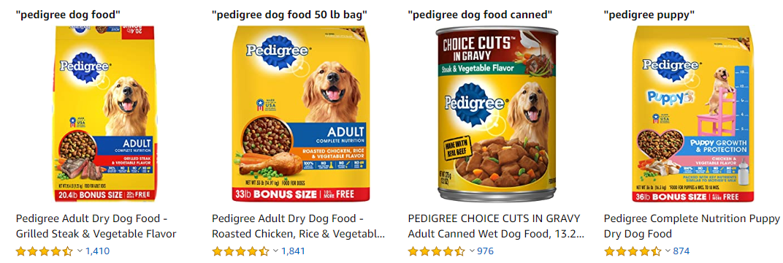

[**Bellotta Food for Cats and Kittens**](https://www.zotezo.com/in/reviews/bellotta-food-for-cats-and-kittens/)

[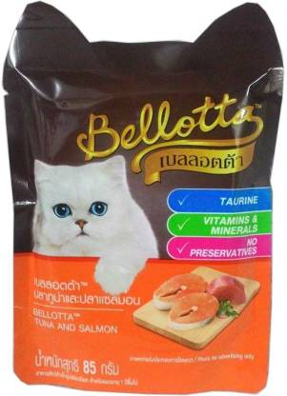](https://www.zotezo.com/in/reviews/bellotta-food-for-cats-and-kittens/)

Bellotta Wet Food for Cats and Kittens ranks first in our list of best cat foods in India. It provides cats with all the essential nutrients necessary for a healthy life. Taurine helps to keep your cat's heart-healthy. Vitamin A helps to improve eyesight in cats while tuna enhances the flavor of their food. Additionally, it is present in food in the form of light brown croquettes. Natural oils bring health and shine to your cats`fur. Some cats are prone to urinary tract infections, but this cat food maintains the health of their urinary tract as well. The crunchy coarse ground food is designed to maintain the oral health by wiping off the plaque and tartar from your cat's gums and teeth. Now you can reserve the best level of love and affection for your cat. You can also order online and have cat food delivered to your doorstep without any hassle.

#### What We Like:

* It has no added preservatives.
* It helps in keeping your cat healthy.
* It provides strong eyesight to your cat.
* It protects your cat from heart-related issues.

#### What We Don’t Like:

* It may not be suitable for all breeds of cats.